SMART ROVER

# APURV CHOUDHARY (20BEC1233), PRATYUSH RAJ (20BEC1273), SAMAL SALUGU JANAKI MANOJ (20BEC1213),

***Abstract--With advancement, human ‘s research interest has been under continuous development, with time humans are evolving by searching about things which are still hidden from the world Owing to this, Accurate, reliability and reachability is really important for data extraction, that is necessary to mitigate any inaccurate observations of a data. The smart rover system is very useful for reachability and smart data extraction, but at the same time is a major challenge in research domain.***

***So, we plan on developing smart rover system. It can be used to extract useful information from places where reachability is limited also it should be noted that data extraction can be done remotely. This may lead to the development of many different types of technologies and artificial habitable systems.***

I. INTRODUCTION

The Smart Rover is a vehicle that has been designed to traverse the rugged areas and extract data of various environments on any surface. Scientists over the years have tried to explore the possibility of life on inhabitable environments like the Antarctic which has extreme cold temperatures. Such explorations have been mostly done using rovers. Hence rovers need to be specially designed to traverse all kinds of terrains and must be equipped with state-of-the-art technology. On many important missions the data that was collected by the smart rovers, using various advanced technologies, which allows us to aggregate data from remote places where human reachability is a great challenge.

A prototype system for smart rover system is presented in this paper. In this study, a BMP280 sensor that is mounted to a vehicle is used to forecast and extract data for in-depth analysis by a researcher professional. If an unusual environmental activity is detected and the consequence of event will be anticipated, the researchers will get to know about the early nature of the environment in which the rover is present, and accordingly the further steps can be taken to explore more about that particular area with more appropriate precautions and information.

II. Literature Review

There are various review papers that give an account of the development of smart rovers from different aspects. Due to the rapid development of smart sensors and related analytical approaches, it is necessary to reillustrate the trends and development frequently. We choose the most highly cited review papers, from 2000 to 2020.

Balakrishnan shankar,Ganesha Udupa,Praveen Basil,Aswath Suresh

The paper describes various issues faced by rover in an alien environment and attempts to solve each of them using innovative design modifications. The rover features a bio-inspired eight-wheeled drive mechanism, an integrated robotic arm and a stereo vision technique for advanced image processing. It assessed whether the selected field site, Gale Crater, had ever offered environmental conditions favourable for microbial life and future investigated the role of water in planetary habitability as preparation for future human exploration

Manash Dey , Harshit Bisht , Rishab Kumar , Abhinav Kumar ,Aman Arora Jatin

Rocker Rover And Its Implementation In The Field Of Agriculture deals with the important aspect of improving the rover from its previous designs. The ROCKER rover has to operate on rough and harsh environments like exploring the Moon’s surface and other expeditions alike for which it was designed. But the implementation of the rocker rover can be further extended in the areas of work where the land upon which the operations needs to be executed like in the field of Agricultural farming. The focus of our research is based on the modification of the rocker rover to applicable in the field of Farming making the agricultural industry much more automated.

Donald M. Hassler,Cary Zeitlin,Robert F. Wimmer-Schweingruber,Bent Ehresmann

In this research paper the rover sent was nasa’s curiosity rover.

Scot RafkinThe Radiation Assessment Detector (RAD) on the Mars Science Laboratory’s Curiosity rover began making detailed measurements of the cosmic ray and energetic particle radiation environment on the surface of Mars on 7 August 2012. We report and discuss measurements of the absorbed dose and dose equivalent from galactic cosmic rays and solar energetic particles on the martian surface for ~300 days of observations during the current solar maximum.

John P. Grotzinger

In this research paper the rover was sent to explore a site located in Gale crater, where a broad diversity of materials was observed from orbit. Materials representing interactions with aqueous environments were targeted for study because of the emphasis on understanding habitable environments. In addition, the mission's science objectives also include characterizing the geologic diversity of the landing site at all scales, including loose surface materials such as impact ejecta, soils, and windblown accumulations of fine sediments.

Samayad Hayati, Arturo Rankin.,Won Kim, Chris leger,

This paper presents four new technology developments and their infusion into the Mars Exploration Rover (MER) mission. These technologies were not ready for infusion prior to the launch of this mission. Three of these new capabilities are designed to increase the level of autonomy for the operations, i.e., fewer ground-in-the-loop steps for executing commands. One of the new capabilities is designed to intelligently filter rover obtained images and return only those that are very likely to contain useful information. These new capabilities will be used for this and future NASA planetary missions.

The survey papers mentioned above focus mostly on the different types of sensors and advanced technologies that can be used for smart rover. To the best of our knowledge, there are no literature surveys that provide a holistic review of smart rover system in terms of data acquisition, data analysis, data transport and storage, sensor networks, and Internet of Things (IoT) platforms, as well as security and privacy, which are significant in the deployment of such systems.

1. Proposed system

The smart rover system consists of the following sensors: BMP 280 which consists of an Altitude sensor, temperature sensor & pressure sensor. The data obtained from these sensors is used to detect the crucial parameters. The sensors are connected to a microcontroller (Node- MCU) which obtains the data from the sensors and processes it continuously to parameters. This microcontroller is connected to a Wi-Fi Module (ESP8266) for the IoT aspect.

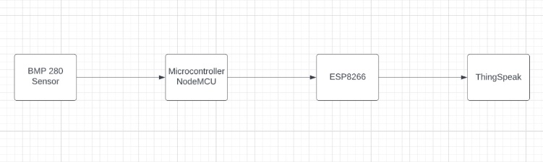

**Figure: Proposed system block diagram**

1. COMPONENTS

HARDWARE COMPONENTS:

* ESP8266-ESP01

The ESP01 ESP8266 is a serial Wifi Wireless

Transceiver Module. It is a self-contained SOC(system of chips) with an integrated TCP/IP protocol stack that can give any microcontroller access to your WiFi network. The ESP8266 is capable of either hosting an application or offloading all Wi-Fi networking functions from another application processor.

* Node MCU

NodeMCU is a low-cost open-source IoT platform.

It initially included firmware that runs on the ESP8266 Wi-Fi SoC from Espressif Systems and hardware that was based on the ESP-12 module

Only one firmware can exist on the ESP8266. It can be either AT Commands Firmware, NodeMCU Firmware or Arduino based code. Once you upload an Arduino sketch, the NodeMCU firmware gets erased. If you want to work with Lua Scripts and NodeMCU, then you have to flash the NodeMCU Firmware.

* BMP 280

The BMP280 is an absolute barometric pressure sensor, which is especially feasible for mobile applications. Its small dimensions and its low power consumption allow for the implementation in battery-powered devices such as mobile phones, GPS modules or watches. The BMP280 is based on Bosch’s proven piezo-resistive pressure sensor technology featuring high accuracy and linearity as well as long-term stability and high EMC robustness. Numerous device operation options guarantee for highest flexibility. The device is optimized in terms of power consumption, resolution and filter performance.

* Arduino UNO

Arduino Uno is a microcontroller board based on the ATmega328P (datasheet). It has 14 digital input/output pins (of which 6 can be used as PWM outputs), 6 analog inputs, a 16 MHz ceramic resonator (CSTCE16M0V53-R0), a USB connection, a power jack, an ICSP header and a reset button. It contains everything needed to support the microcontroller; simply connect it to a computer with a USB cable or power it with a AC-to-DC adapter or battery to get started

S**OFTWARE COMPONENTS:**

* Arduino IDE

Arduino IDE or Arduino Integrated Development Environment is a cross-platform application that is written in functions from C and C++. It is used to write and upload programs to Arduino compatible boards. This application works on all operating systems namely Windows, macOS, and Linux. Arduino IDE supplies a software library from the wiring project, which provides many common input and output procedures.

* THINGSPEAK

Using the ThingSpeakTM IoT analytics platform service, you can gather, visualise, and examine realtime data streams in the cloud. Data sent by your devices to ThingSpeak is instantly visualised by ThingSpeak. With the help of ThingSpeak, data can be sent from devices, websites, and sensors to the cloud and stored in either a private or public channel. By default, ThingSpeak keeps data in private channels, however data can also be shared in public channels.

* 1. METHODOLOGY

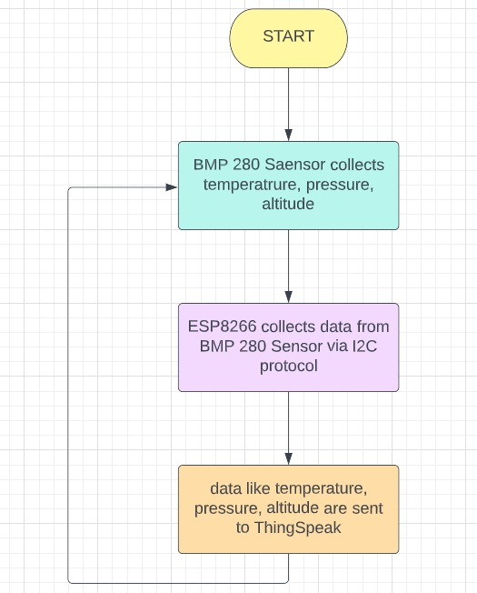

**Figure: Flowchart of the methodology used.**

* 1. RESULTS.

The following is the result

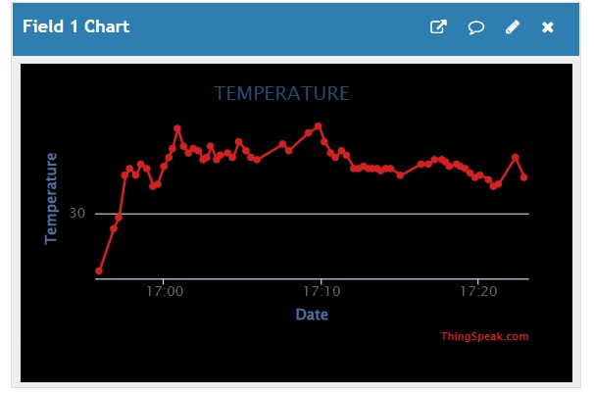

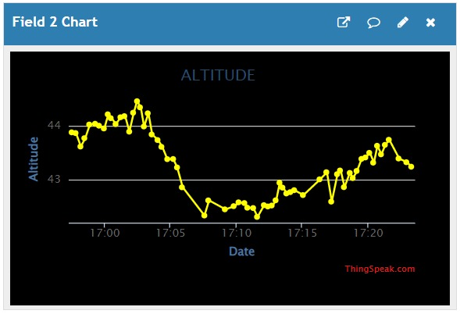

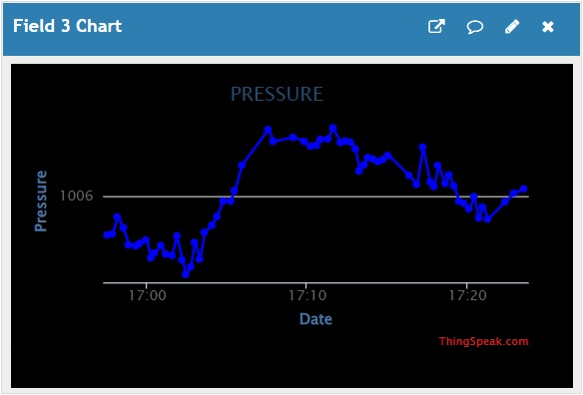

* 1. CONCLUSION

The smart rover vehicle has been built successfully and from the results, it has performed well in the tests as well.

The device is compact enough to be send to remote places and hence it can be used by researchers without compromising on data.

The analytics also helps us determine the nature of the environment where we are testing the rover.

IX. FUTURE WORKS

The existing model can be modified for:

* Data Analysis using ML
* Data Extraction at faster rate
* Data Extraction at Longer distance
* Data Extraction can be more Accurate
* More Stable and safe vehicle

X. REFERNECES

<https://www.researchgate.net/publication/337388672_Rocker_Rover_And_Its_Implementation_In_The_Field_Of_Agriculture_A_Review?enrichId=rgreq-eb4e2b65d69019d4fb327ff45dff5fde-XXX&enrichSource=Y292ZXJQYWdlOzMzNzM4ODY3MjtBUzo4MjcyNDM5NDk0NjE1MDdAMTU3NDI0MTczNTkxNQ%3D%3D&el=1_x_2&_esc=publicationCoverPdf>

[[PDF] Design and Development of an Intelligent Rover for Mars Exploration(Updated) (researchgate.net)](https://www.researchgate.net/publication/325120171_Design_and_Development_of_an_Intelligent_Rover_for_Mars_ExplorationUpdated)

[Mars’ Surface Radiation Environment Measured with the Mars Science Laboratory’s Curiosity Rover | Science](https://www.science.org/doi/10.1126/science.1244797?siteid=sci&keytype=ref&ijkey=O0XhFmLAOd8IY)

[Analysis of Surface Materials by the Curiosity Mars Rover | Science](https://www.science.org/doi/full/10.1126/science.1244258?siteid=sci&keytype=ref&ijkey=zmigLCW740i4k)